**Problem**

Today, people are continuously looking for natural alternatives to maintain their personal health. Bacteria has evolved to become immune to many man made treatments, so people are looking for natural ways to protect themselves. Proanthocyanidins found in grape seeds have been known to possess beneficial attributes, so in this study, we are testing whether grape seed proanthocyanidin has any antibacterial properties. Can grape seed extract be used as an effective antibiotic to Staphylococcus Epidermidis?

###### **Hypothesis**

Grape Seed Proanthocyanidin Extract should inhibit the growth of Staphylococcus Epidermidis.

If Grape Seed Proanthocyanidin is effective in controlling bacterial growth, then when placed in a bacteria-rich medium, zones of inhibition should be greater than those without the treatment.

# **Introduction**

The human diet has evolved over the course of time to include foods that possess both mentally and physically healthy attributes. By eating healthy foods and avoiding those that are less desirable, a person has been noted to achieve longevity and better health. In addition to eating “regular” foods, nutritional supplements also offer valuable nutrients. The history of dietary supplements and alternative forms of medicine have existed for many years, and several of these ancient remedies have paved the way for more extensive studies into the benefits of “natural cures.” During the 1970’s a French Professor, Jacques Masquelier of the University of Bordeaux, France, used the observations of an ancient French explorer from the 1500’s to base his own studies. The French explorer, Jacques Cartier, was traveling in North America when his men became afflicted with scurvy, caused by a lack of Vitamin C. Cartier wrote about how they were cured when an Indian Native recommended that they drink tea made from the bark of pine trees. Because vitamin C is the cure for scurvy, Masquelier assumed that vitamin C was present in the tree bark. After further analysis of the bark and extended studies into grape seeds, Professor Masquelier discovered the presence of a different nutrient, Proanthocyanidins.

Proanthocyanidins are naturally occurring polyphenolic bioflavonoids widely available in fruits, vegetables, nuts, seeds, flowers, and bark (1). Grape seed and pine bark extracts are both excellent sources of proanthocyanidin, yet because the majority of studies have been performed on *grape seed* proanthocyanidin, it has become the preferred product. Professor Masquelier also demonstrated that grape seed extract is more effective because it has “gallic esters.” The “gallic esters,” which are not present in bark extract, are the most active component of the bioflavonoids (14). Other than proanthocyanidins, grapes contain other antioxidants including resveratrol, catechin, and epicatechin (2). While the resveratrol is primarily located in the skin of the grape, Proanthocyanidins are most abundant in the seeds (Kovac et l., 1995).

Although proanthocyanidins are the main subject of this study, the study of grapes as being a beneficial bioflavonoids also began when Drs. Langcake and Pryce discovered the presence of resveratrol in grapevine tissues (13). Dr. Langcake and Dr. Pryce later became aware that resveratrol was a natural antibiotic produced by plants to fight off fungi, bacteria, or viruses. With this knowledge the doctors continued to perform studies about the effects of resveratrol on humans. It was through these early pioneers that grape seed proanthocyanidin would be extensively studied.

PROANTHOCYANIDIN AS AN ANTIOXIDANT

The Proanthocyanidin found in grape seed extracts are “antioxidants which are known to possess a broad spectrum of biological, pharmacological and chemoprotective properties” (6). As an antioxidant, proanthocyanidins inhibit the destructive properties of free radicals found throughout the body. The chemical makeup of bioflavonoids provides available hydrogen atoms as “free radical scavengers” (5). Free radicals are reactive molecules that cause the “oxidative deterioration of cell tissues, lipids, proteins, and DNA” (4). Virtually unavoidable, free radicals enter the body as a result of daily exposures and activities such as, exercise, stress, smoking, pesticides, pollution, sunlight, and also the “body’s natural process of metabolizing air” (4). Furthermore, free radicals have been attributed to causing many diseases, including arthritis, cardiovascular diseases, tumors, and organ deterioration (4,5). Although vitamins from fruits and vegetables should be sufficient in fighting off naturally acquired free radicals, humans have created an environment less suited for natural remedies. Abundant with pollution, pesticides, and a depleted ozone layer, humans have dramatically increased the intake of free radicals, and made natural vitamins insufficient. In response to the exceeding amount of free radicals, scientists have extensively studied the beneficial effects of antioxidants.

Proanthocyanidins have shown significant antioxidant capabilities in numerous ways. Grape seed extract has been used in cardiovascular, cancer, drug, and antioxidant research. When compared with Vitamins C, E, and beta-carotene, grape seed proanthocyanidin showed “significantly greater protection against oxygen free radicals” (7). Furthermore, proanthocyanidins have shown results in protecting against the harmful effects of smoking. Tobacco use increases the consumption of free radicals and causes **apoptosis**, which is the death of a cell in “pathological conditions” (7). Apoptosis is triggered by a high content of free radicals, and is linked with several diseases such as cancer, heart disease, and Alzheimer’s disease (9). During a study done by Doctor M. Bagchi, grape seed proanthocyanidin extract reduced apoptosis in tobacco treated cells by 85%, while a combination of vitamins C and E reduced apoptosis by only 46% (7). According to this study it can be concluded that grape seed proanthocyanidins may potentially reduce the chances of cancers created by tobacco use.

An increase in cardiovascular diseases has also prompted research into alternative dietary solutions. A study by Dr. Bagchi and his colleagues was done to observe whether grape seed extract possesses cardioprotective properties. Rats were given grape seed proanthocyanidin to examine the effect of the extract on the heart. After submitting the hearts to **ischemia**, which is blocking the flow of blood, the blood flow was restored (called **reperfusion**). It is through reperfusion that the heart receives the most oxidative damage to the muscle (2,8). The results of the experiment showed that hearts treated with the grape seed extract recovered better after reperfusion than those without (8). Damage to the hearts were also significantly less when the proanthocyanidin was present (2).

Due to many promising reports about the beneficial effects of proanthocyanidins on tobacco caused cell death, scientists decided to test bioflavonoids on cancerous cells. Human breast and lung cancer cells, along with stomach and leukemic cells were used to observe the potency of proanthocyanidins. The results of the experiments were very promising and suggested that grape seed proanthocyanidin (GSPE) could potentially be a tool in curing cancer. *“Following incubation of the breast cancer cells with 25mg/L of GSPE, approximately 7%, 30%, 43% reductions in cell growth were observed at 24, 48, and 72 hours, respectively, while incubation of the breast cancer cells with 50mg/L of GSPE, resulted in 11%, 35%, and 47% inhibition in cell growth at these same time points , respectively” (10).* In addition to the breast cancer cells, the lung cancer and the stomach cells provided similar results (10). As indicated by this study, the grape seed extract (GSPE) had considerable effect on a few of the leading forms of cancer in the US.

CULTURAL EVIDENCE

Diets vary among different cultures, and as a result, different races of people are more immune to certain illnesses than others. Developed countries such as the United States and the United Kingdom have a strong correlation between the intake of fatty foods and the mortality rate from heart disease, yet France exhibits a discrepancy in this claim. It is a known fact that fatty foods, high in saturated fat and cholesterol, are primary causes of coronary heart disease. Although the French population maintains a highly fat diet, the natives seem to have a low incidence of coronary diseases. In order to explain France’s immunity to heart diseases, scientists turned to analyzing the diets of French people. Coined the “French Paradox,” scientists have associated this phenomena with the strong presence of wine in the French diet (3,13).

Another group of people that have shown evidence of bioflavonoids protection are Asians. Breast, ovarian, and prostate cancers among Asians is significantly less than other races due to higher blood levels of phytoestrogens (13). Phytoestrogens are compounds found in plants that assume similar characteristics to that of steroidal estrogens produced by the body. According to recent studies phytoestrogens “exhibit anticarcinogenic” properties by protecting against “estrogen-dependent” cancers such as breast and prostate cancer (13). These bioflavonoids are separated into three classes; isoflavonoids, phytoalexins, and coumestans. Phytoalexins are primarily found in grapes and in turn found in wine. Isoflavonoids, on the other hand, are found in tofu and miso, which are heavily consumed in the Asian culture (13).

Bioflavonoids such as grape seed proanthocyanidins and others found in fruits and vegetables have continuously proven themselves as being an asset to the human diet. Historical and present day evidence has surfaced which has encourage extensive research in this field. Because there is a possibility of naturally protecting against incurable diseases such as cancer and heart disease, bioflavonoids will always be a topic of research.

PROANTHOCYANIDIN IN WINE

Historically, wine has been noted as one of the oldest and most cherished drinks because of its use for medicine and pleasure. The medicinal uses of wine even date back to biblical times when Noah “raised grapes and made wine” (13). The study of grapes and wine has had an extensive history that has carried itself into the scientific world today. In an attempt to uncover why wine has such an advantageous effect on health, scientists have incorporated the study of grape seed, skin, and pulp into their research.

Heart disease has become a major health issue in America, accounting for one in three deaths of every human (13). In spite of this great number of deaths attributed to heart disease, France has a significantly less mortality rate from coronary problems. The bioflavonoids present in grapes allow wine to posses antioxidant characteristics that actually help the body. It is estimated that if every adult in North America drank two glasses of red wine, deaths from heart disease would reduce by 40 percent (13). In addition to the grapes, alcohol also possesses healthful attributes. “Alcohol in wine, if consumed in small amounts, increases the amount of beneficial cholesterol (high density lipoprotein cholesterol) and reduces platelet coagulability” (13). The antioxidants from the grapes protect against the unhealthy cholesterol (low-density lipoprotein cholesterol). After studying the effects of wine, researchers deduced that red wine has a higher antioxidant potency. Unlike white wine, red wine is fermented in the presence of grape skin and the grape seeds which contain high concentrations of proanthocyanidins (5).

Because grapes have such a wide variety of beneficial attributes we decided to see if grape seed proanthocyanidin possessed antibacterial properties.

## **Raw Data**

This data was collected 3 days after bacteria was incubated. The day number refers to the day that the bacteria was checked, not the length of time spent in incubation. The method of measuring the zones of inhibition are also easily subjected to human error because the zones are sometimes inconsistent around the chromatography paper.

## Day 1

*1% Concentration of Grape Seed Extract*

|  |  |  |  |  |  |  |
| --- | --- | --- | --- | --- | --- | --- |
|  | **A** | **B** | **C** | **D** | **E** | **F** |
| Plate 1 **zone of inhibition** | 5mm | 6.5mm | 7mm | 5.5mm | 5.5mm | 5mm |
| Plate 2 **zone of inhibition** | 5.5mm | 5.5mm | 5.5mm | 7.5mm | 6.5mm | 5mm |

*.75% Concentration of Grape Seed Extract*

|  |  |  |  |  |  |  |
| --- | --- | --- | --- | --- | --- | --- |
|  | **A** | **B** | **C** | **D** | **E** | **F** |
| Plate 1 **zone of inhibition** | 3mm | 3.5mm | 5mm | 6mm | 5.5mm | 5mm |
| Plate 2 **zone of inhibition** | 6mm | 6.5mm | 6mm | 3.5mm | 5mm | 5.5mm |

*.5% Concentration of Grape Seed Extract*

|  |  |  |  |  |  |  |
| --- | --- | --- | --- | --- | --- | --- |
|  | **A** | **B** | **C** | **D** | **E** | **F** |
| Plate 1 **zone of inhibition** | 5mm | 2mm | 4mm | 3mm | 2mm | 2.5mm |
| Plate 2 **zone of inhibition** | 4mm | 3.5mm | 3mm | 3.5mm | 4mm | 4.5mm |

*.25% Concentration of Grape Seed Extract*

|  |  |  |  |  |  |  |
| --- | --- | --- | --- | --- | --- | --- |
|  | **A** | **B** | **C** | **D** | **E** | **F** |
| Plate 1 **zone of inhibition** | 2mm | 2.5mm | 3.5mm | 1.5mm | 2.5mm | 3mm |
| Plate 2 **zone of inhibition** | 1.5mm | 3mm | 2.5mm | 1mm | 3mm | 2mm |

Water (control)*

|  |  |  |  |  |  |  |
| --- | --- | --- | --- | --- | --- | --- |
|  | **A** | **B** | **C** | **D** | **E** | **F** |
| Plate 1 **zone of inhibition** | 0 | 0 | 0 | 0 | 0 | 0 |
| Plate 2 **zone of inhibition** | 0 | 0 | 0 | 0 | 0 | 0 |

*The control (water) showed no change over the course of 3 days so the chart was not repeated

Day 2

*1% Concentration Grape Seed Extract*

|  |  |  |  |  |  |  |
| --- | --- | --- | --- | --- | --- | --- |
|  | **A** | **B** | **C** | **D** | **E** | **F** |
| Plate 1 **zone of inhibition** | 4.5mm | 5.5mm | 2mm | 4mm | 3.5mm | 3mm |
| Plate 2 **zone of inhibition** | 5mm | 3mm | 5mm | 6mm | 5.5mm | 4.5mm |

*.75% Concentration of Grape Seed Extract*

|  |  |  |  |  |  |  |
| --- | --- | --- | --- | --- | --- | --- |
|  | **A** | **B** | **C** | **D** | **E** | **F** |
| Plate 1 **zone of inhibition** | 2.5mm | 3mm | 4mm | 3.5mm | 2.5mm | 2mm |
| Plate 2 **zone of inhibition** | 4mm | 5.5mm | 5mm | 3mm | 2mm | 2.5mm |

*.5% Concentration of Grape Seed Extract*

|  |  |  |  |  |  |  |
| --- | --- | --- | --- | --- | --- | --- |
|  | **A** | **B** | **C** | **D** | **E** | **F** |
| Plate 1 **zone of inhibition** | 4.5mm | 1mm | 4mm | 2.5mm | 1.5mm | 2mm |
| Plate 2 **zone of inhibition** | 3.5mm | 2mm | 2mm | 2.5mm | 1.5mm | 2.5mm |

*.25% Concentration of Grape Seed Extract*

|  |  |  |  |  |  |  |
| --- | --- | --- | --- | --- | --- | --- |
|  | **A** | **B** | **C** | **D** | **E** | **F** |
| Plate 1 **zone of inhibition** | 1mm | 1.5mm | 2mm | 1.5mm | 1mm | 2mm |
| Plate 2 **zone of inhibition** | 1mm | .5mm | .5mm | 1mm | .5mm | 1mm |

### **Day 3**

*1% Concentration of Grape Seed Extract*

|  |  |  |  |  |  |  |
| --- | --- | --- | --- | --- | --- | --- |
|  | **A** | **B** | **C** | **D** | **E** | **F** |
| Plate 1 **zone of inhibition** | 2mm | 2mm | 1.5mm | 3mm | 0mm | 0mm |
| Plate 2 **zone of inhibition** | 2mm | 2mm | 1.5mm | 3mm | 1mm | 0mm |

*.75% Concentration of Grape Seed Extract*

|  |  |  |  |  |  |  |
| --- | --- | --- | --- | --- | --- | --- |
|  | **A** | **B** | **C** | **D** | **E** | **F** |
| Plate 1 **zone of inhibition** | 2mm | 3mm | 1.5mm | 0 | 0 | 0 |
| Plate 2 **zone of inhibition** | 2mm | 2mm | 0 | 0 | 0 | 0 |

*.5% Concentration of Grape Seed Extract*

|  |  |  |  |  |  |  |
| --- | --- | --- | --- | --- | --- | --- |
|  | **A** | **B** | **C** | **D** | **E** | **F** |
| Plate 1 **zone of inhibition** | 0 | .5mm | .5mm | 0 | 0 | 0 |
| Plate 2 **zone of inhibition** | 0 | 0 | 0 | 0 | 0 | 0 |

*.25% Concentration of Grape Seed Extract*

|  |  |  |  |  |  |  |
| --- | --- | --- | --- | --- | --- | --- |
|  | **A** | **B** | **C** | **D** | **E** | **F** |
| Plate 1 **zone of inhibition** | 0 | 0 | 0 | 0 | 0 | 0 |
| Plate 2 **zone of inhibition** | 0 | 0 | 0 | 0 | 0 | 0 |

**Analysis**

*This table displays the average zone of inhibition measurement for each concentration of grape seed extract calculated from the raw data. From this data we can see that as the concentration decreases the average zone of inhibition also decreases. We use the water (control) as a basis of comparison to show that the grape seed extract is actually having some effect on the bacteria. From day to day the average zones of inhibition progressively get smaller and smaller.*

*(fig 1.a)*

# DAY 1

|  |  |
| --- | --- |
| *Concentrations of (GSPE)* | *Average zone of inhibition (mm)* |
| 1% | 5.83 |
| .75% | 5.04 |
| .5% | 3.41 |
| .25% | 2.33 |
| 0% (Water only) | 0 |

*(fig 1.b)*

# DAY 2

|  |  |
| --- | --- |
| *Concentrations of (GSPE)* | *Average zone of inhibition (mm)* |
| 1% | 4.29 |
| .75% | 3.29 |
| .5% | 2.46 |
| .25% | 1.13 |
| 0% (Water only) | 0 |

*(fig 1.c)*

## DAY 3

|  |  |
| --- | --- |
| *Concentrations of (GSPE)* | *Average zone of inhibition*  *(mm)* |
| 1% | 1.5 |
| .75% | .875 |
| .5% | .542 |
| .25% | 0 |
| 0% (Water only) | 0 |

*These tables show the average zones of inhibition for Grape Seed Extract over a 3 day period at different concentrations. Visually we can see all 4 concentrations for each day. Notice that the zones of inhibition all get progressively smaller as the days pass.*

*(fig 2.a)*

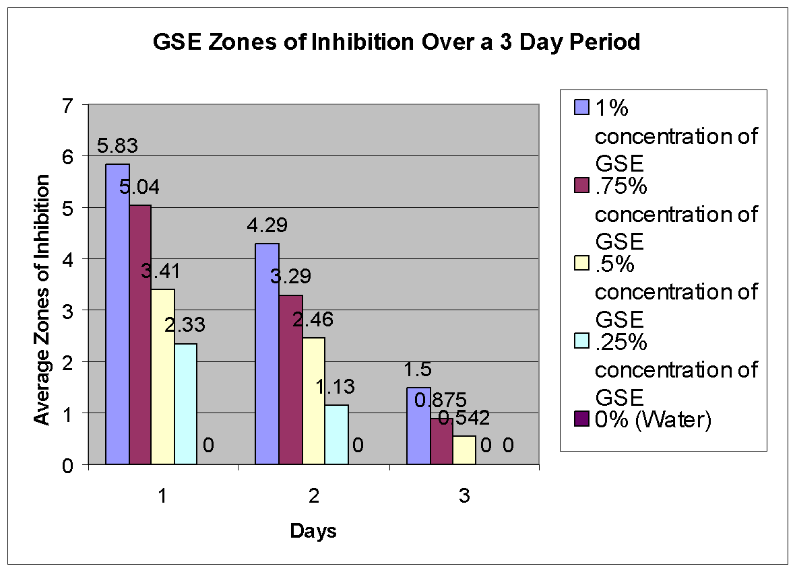

*(fig 2.b)*

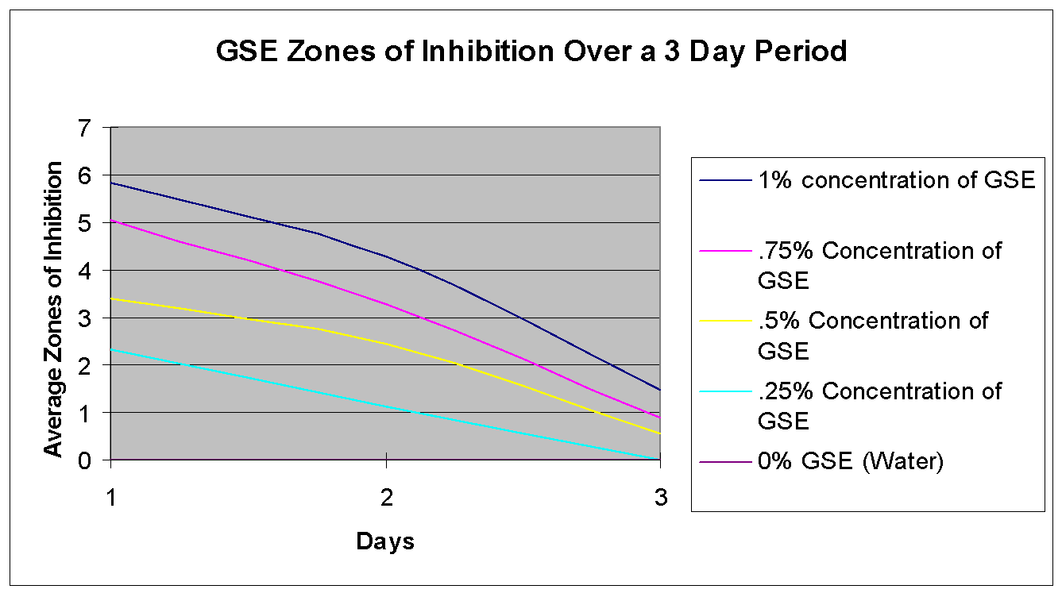

*These tables represent a 95% Confidence Interval of the zones of inhibition for each day and concentration. The Confidence Interval(CI) states that in future studies 95% of all zone averages will fall in the CI range. Each mark on the lines represent the observed averages in this study.*

*(fig 3.a)*

|  |  |
| --- | --- |
| **Concentrations** | 95% Confidence Interval |
| 1% | 5.83 +/- 0.426 |
| .75% | 5.04 +/- 0.643 |
| .5% | 3.41 +/- 0.537 |
| .25% | 2.33 +/- 0.424 |

*(fig 3.b)*

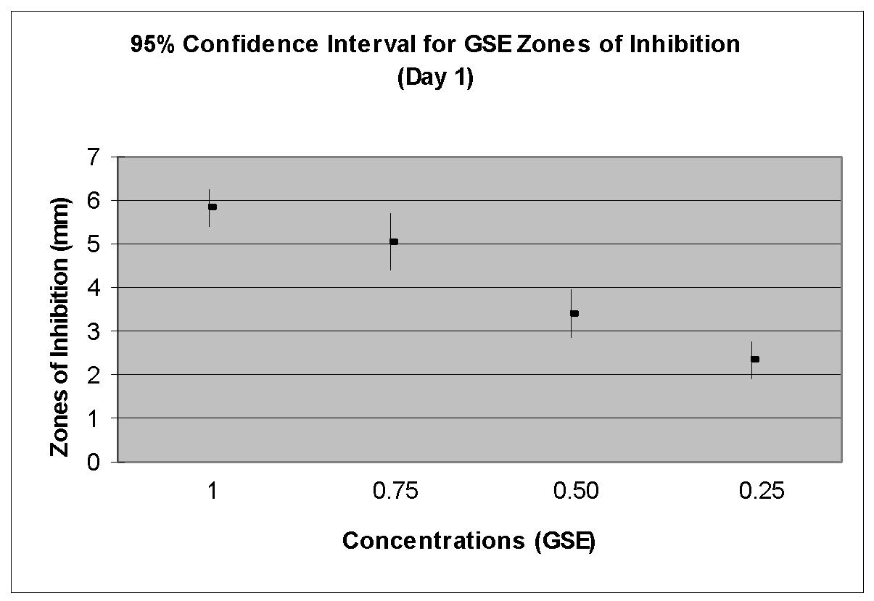

*(fig 4.a)*

|  |  |
| --- | --- |
| **Concentrations** | 95% Confidence Interval |
| 1% | 4.29+/- 0.6846 |
| .75% | 3.29 +/- 0.643 |
| .5% | 2.46 +/- 0.596 |
| .25% | 1.13 +/- 0.299 |

*(fig 4.b)*

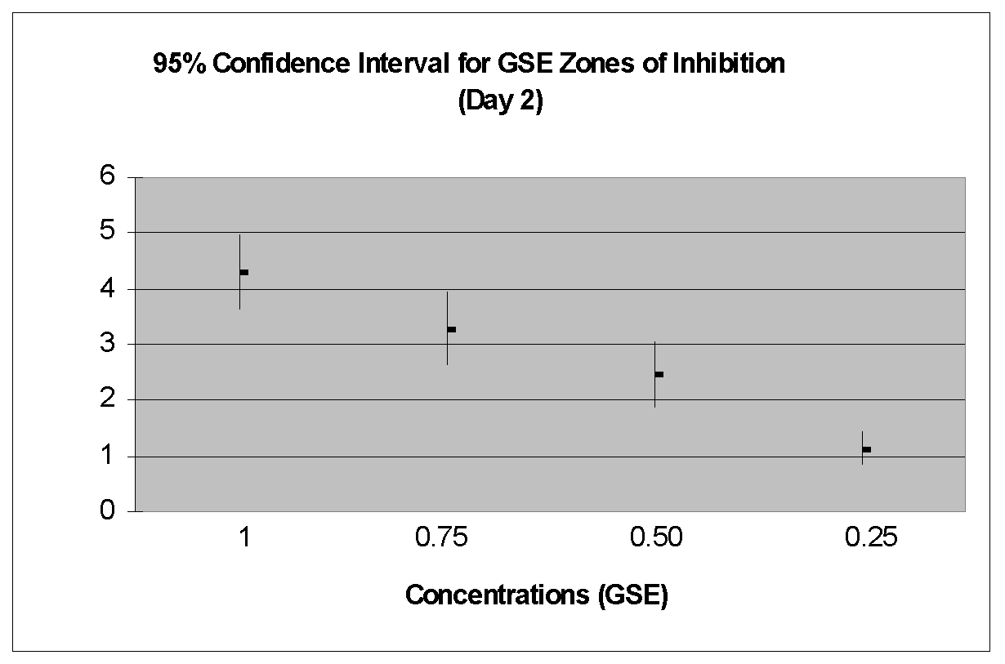

*_____________________________________________________________________________*

*(fig 5.a)*

|  |  |
| --- | --- |
| **Concentrations** | 95% Confidence Interval |
| 1% | 1.5 +/- 0.603 |
| .75% | 0.875 +/- 0.639 |
| .5% | 0.083 +/- 0.562 |
| .25% | 0 (no zones of Inhibition) |

*(fig 5.b)*

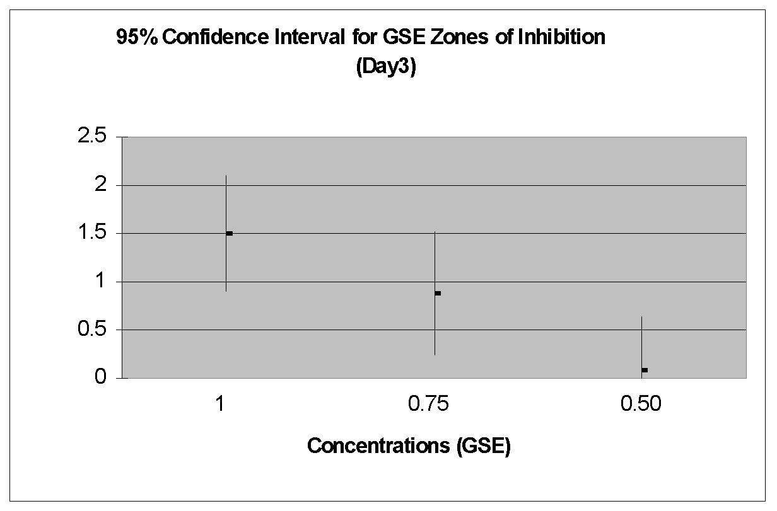

Figure 6 displays the average zone of inhibition related to the concentration of GSE for each day. Notice how the zones of inhibition decrease for each day and also have a positive correlation between the concentration and the zones of inhibition.

*(fig 6.a)*

|  |  |  |
| --- | --- | --- |
| **Day** | Concentration (%) | Avg. Zone of Inhibition (mm) |
| **Day 1** | 1  .75  .5  .25  0 | 5.83  5.04  3.41  2.33  0 |
| **Day 2** | 1  .75  .5  .25  0 | 4.29  3.29  2.46  1.13  0 |
| **Day 3** | 1  .75  .5  .25  0 | 1.5  .875  .083  0  0 |

*(fig 6.b)*

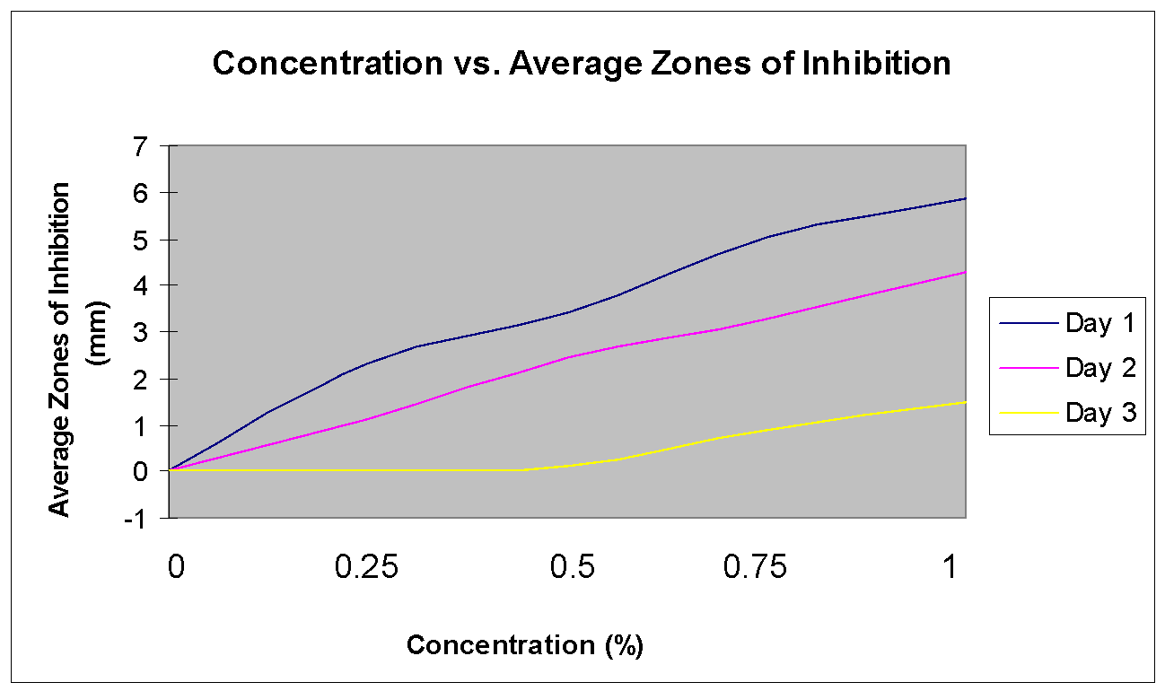

**Statistical Analysis**

In order to show that there is a significant difference between the mean zones of inhibition for each concentrations of grape seed extract, we performed a statistical **ANOVA** test. After inputting all of the **raw** data into a calculator, the calculator finds each mean and calculates a P-value. The P-value is significant at .05 to reject the null hypothesis and accept the alternative hypothesis.

For each day the Ho and Ha are:

**Ho:** According to our null hypothesis the average zones of inhibition for each concentration are the same. (undesired)

**Ha:** According to our alternative hypothesis, the average zones of inhibition for each concentration are not the same. (desired)

(refer to figure 1.a-1.c)

|  |  |  |
| --- | --- | --- |
| **DAY** | **F value** | **P-value** |
| Day 1 | 35.69 | 7.46x10-12 |
| Day 2 | 207.73 | 1.59x10-8 |
| Day 3 | 9.86 | 4.2x10-5 |

Because the P-values are all less than .001 we reject the null hypothesis (Ho) and the notion that the average zones of inhibition are the same for each concentration of grape seed extract. This test does not indicate which average is largest or smallest, but we can conclude this from data in figures 1,2, and 6. These graphs indicate that the larger concentrations are more effective at inhibiting the growth of Staphylococcus Epidermidis.

**Conclusion**

After close analysis of the data it is apparent that Grape Seed Extract is a deterrent against bacterial growth, specifically Staphylococcus Epidermidis. Not only do Proanthocyanidins function as an effective antioxidant, but also as an antibiotic. With the ongoing studies about natural supplements it is no surprise that another beneficial attribute can be linked to these bioflavonoids.

The data taken after three days reflects that the growth of staphylococcus Epidermidis is significantly inhibited by the presence of the Proanthocyanidin grape seed extract. The research done does not conclude that grape seed extract kills already formed bacteria, but it certainly exhibits evidence as an antibiotic. According to the data, the higher concentrations of Proanthocyanidins seem increase its longevity as an antibiotic. As the concentrations of the grape seed extract increased, the effectiveness also increased. Over a three day period the rate of a zone shrinkage was far greater with the lower concentrations of GSE (figures 1,2,6). Because we diluted the grape seed extract in distilled water, we used distilled water as our control. The control group showed no zones of inhibition after

It is obvious, from looking at the graphical analysis and tables, that there is a difference in the means of the zones of inhibition. To strengthen this claim we performed a statistical ANOVA test to show that the average zones of inhibition are significantly different. The use of an ANOVA test was also documented in previous studies regarding grape seed extract. According to the test, there is a very low probability that the observed values of the zones of inhibition were reached by chance alone. This means that there is some characteristic, within the grape seed extract, that directly affects that growth of the bacteria. Because an active ingredient in grape seeds is the Proanthocyanidins, it can be concluded that Proanthocyanidins are the acting antibiotic.

The use of a 95% confidence interval also adds statistical validity to our study; refer to figures 3-5. The confidence interval states that in future studies 95% of all the averages will be captured in this range. Because the confidence intervals were fairly small, it adds to the strength of our observations. The small confidence intervals suggest that the individual pieces of data did not stray far from the average zone of inhibition. From this, we can conclude that the zones of inhibition were fairly uniform throughout **all** the samples.

Grape seed proanthocyanidin is an antioxidant that has been known to posses cardio-protective, chemo-protective, and now antibacterial properties. From this study, we can conclude that:

1. Grape seed extract is an agent in preventing the growth of staphylococcus Epidermidis,
2. it is most effective at higher concentrations, and
3. the effects of the antioxidant are short lived.

This study has opened the door for further study into the antibiotic properties of grape seed extract, and the effects of bioflavonoids in general. If continuing studies are done on the beneficial characteristics of fruits and vegetables, inexpensive and bio-available cures may by a valuable consequence.

**Recommendations**

In attempting to create an ideal experiment utilizing the basic principles of the scientific theory, we understand our efforts may have fallen short in certain categories. Although we don’t regret attempting, there are several nuances of the procedural process that surely can be improved upon. In addition, discoveries in our research could possibly help to lead future teams in conquering the scientific process and also expanding upon the groundwork, which we have laid in the realm of antioxidants, such as Grape Seed Extract.

-Shaun and Delaney

# Advice – In General

1. In any large-scale scientific venture remember that others before you have probably pondered in some form or another the ideas that your team has been kicking around. Be sure to max out all your resources. Everyone is willing to help people, (especially kids) who want to better our planet or discover how and why it works the way it does. Anyone in the teaching profession is always willing to give some kind of guidance, however small or insignificant. The trick is to find someone who wants to help you, or has an interest in the topic. To maximize your searchable network of scientists, physicians, professors or researchers use the Internet.
2. Find a topic that shows potential as a source of long-term interest to your team. Whether is is something that you have experience in, or something that is completely unknown to you. It is important, not only as a source of inspiration, but as something that can last, and even blossom into a career. But, don’t think of the project as something groundbreaking, it can be an avenue of expression or a foundation for those who follow in your footsteps.
3. Finally, observe the boundaries on yourself. Realize that doing too much is a possibility. Don’t overstep your boundaries and put unneeded pressure on yourself as far a deadlines go and the physical constraints during your procedure.
4. Be safe and have fun!!!

# Advice – Specifically Related to this Procedure

1. Use a sterile and sanitary work environment in the growth and cultivation of any bacteria.
2. Any variation in the strain of bacteria used in this experiment can be harmful. Carolina was very glad to provide the complete genetic make-up of it, so our team realized it’s boundaries.
3. The cotton swab might have worked more effectively at spreading a thorough bacteria lawn than the inoculation loop.
4. Little if no bacteria growth on the first couple days means nothing.
5. Be sure to have a procedure ready to go before ordering a the bacteria, and make sure that you reserve time in the classroom to work.
6. The notion of GSE aiding in the fight against heart disease is a topic that should have been pursued by this group. With so many potential “wonder drugs” it is important to question their validity and look for alternative sources of aide.

**Log**

August

11. Brainstorming

Shaun and Delaney get together at Borders Book Store and begin to review scientific journals and texts pertaining to grapes and their potential health-related benefits. Soon, attention is drawn to the fact that much of the nutritional value of grapes stems from their ability as antioxidants to slow down the growth of rapidly dividing cells.

17.Researching

At the Pleasanton Library Shaun and Delaney research material regarding the origin and current medicinal uses of Grape Seed Extract (commonly called GSE). The “Life Sciences” section at the library was the most applicable section pertaining to the topic of antioxidants.

23.Contacting

Shaun and Delaney utilize the vast Internet at their own personal computers to contact as many people as they can that have significant knowledge of the topic. It is apparent that many professors in the higher levels of learning want to deal with such topics, and with such research teams as Shaun and Delaney.

29. Researching

While swapping resources on their topic, Shaun and Delaney find that their topic is very open-ended and the issue of Grape Seed Extract as a topically applied solution to skin, as a preventative against uv-rays and cancer is soon apparent.

September

10.Brainstroming

After talking with their teacher, Eric Thiel, Shaun and Delaney feel that the topic of uv-rays and cancer is a solid topic, and one that will surely hold their interest.

13.Researching

Very little is actually know about the causes of skin cancer and so the simple application of the GSE might be more difficult than previously thought.

14. Brainstorming

Shaun finds a very valuable resource to the team in Professor Bagchi of Creighton University in Nebraska. As a long time researcher of GSE, Professor Bagchi is able to focus the attention of the team on the use of GSE as a simple antioxidant. Through his research with a Concord, CA based company Inter Health, Shaun is able to contact a source at Inter Health that heads research related to the topic of the team, and provides them with information about Activin and it’s testing (Activin is the name used for this certain chemically altered GSE). This later lead Shaun and Delaney to obtain their testing source of GSE for their experiment, in a pure unaltered form.

19. Focusing

Now that Shaun and Delaney have decided on an avenue to pursue their research they begin to define the complex vocabulary terms which they were presented in the one-hundred page packet from Inter Health.

October

6.Contacting

Professor Bagchi is able to communicate via e-mail many times with Shaun and Delaney, the result being they have much more basic knowledge of where GSE research is headed today. Current trends in the scientific world, procedures etc.

November

10. Researching

Using the procedure already in place by a team the previous year, the team decides on a basic plan of action.

December

13.Ordering

Bacteria is ordered via one of the most recognized scientific materials providers Carolina.

17. Arriving

Bacteria arrives along with 10 Nutriendt Agar Plates.

January

4. Requesting

The pure form of GSE is not found at any of the local nutrition stores in Pleasanton, and further research is needed to find one-hundred percent pure GSE.

10. Contacting

The contact at Inter Health agrees to send the team, free of charge, pure GSE is easily dilatable powder form.

February

7. Researching

Much more research about GSE and the bacteria is needed before a solid procedure can be devised.

9. Researching

Zones of Inhibition appear to show the greatest amount of difficulty in understanding, but with help from the Internet and past experiments the team soon finds a usable procedure.

March

27.Waiting

After a much waiting, the team obtains help from another team working with a similar procedure and soon the experiment will take place.

April

2. Testing

To assure that the experiment will be done with absolute precision bacterial growth is initiated on a sample Nutrient Agar Plate to establish that bacteria growth will occur during the experiment.

3. Observing

No bacteria growth as of yet. Shaun thinks that maybe the oven is turned up to it’s highest temperature to provide for growth.

4. Viewing

Now the experiment can begin, because the sample exhibits ample growth. This pleases the team, but they acknowledge that slow bacteria growth is inevitable and is noted when preparing the procedure for the following day.

5. Problem Solving

Shaun and Delaney spend lunch and after school finding out what concentrations to prepare for the next day, because unfortunately they are unable to begin the experimental process as scheduled.

6. Initiating

At last the concentrations are prepared, the Bunsen burner is ready and the bacteria is still alive. The experiment begins and successfully and is documented using a digital camera and log.

9. Problem Solving

No growth is seen during the weekend, but today growth is apparent and the zones will be measured at lunch and after school.

10. Documenting

Using Mr. Thiel’s digital camera, all the data from the petri dishes can be chronicled on the computer and will soon be made available for everyone to view on the World Wide Web. Also, another day of observing the zones is a success, because the zones are shrinking, as they should.

11. Recording

Final day of recording data is completed and a source is found in Shaun and Delaney’s AP Statistics Teacher Mrs. Nash to help analyze the data observed and formulate a solid conclusion. Specifically, the use of the ANOVA Test, which is the comparison of several means and the use of confidence intervals.

**Bibliography**

1. D. Bagchi., A. Garg, R.L. Krohn, M. Bagchi, M.X. Tran. and S.J. Stohs. “Oxygen Free Radical Scavenging Abilities of Vitamins C and E, and A Grape Seed Proanthocyanidin Extract In Vitro.” Vol. 95, No.2. Feb. 1997.
2. M. Sato, G. Maulik, P.S. Ray, D. Bagchi, D.K. Das. “Cardioprotective Effects of Grape Seed Proanthocyanidin Against Ischemic Reperfusion Injury.” J Mol Cell Cardiol 31, 1289-1297 (1999).
3. D.A Tyson, N.A. Talpur, B. Echard, D. Bagchi, B. Echard. “Acute Effects of Grape Seed Extract and Niacin-Bound Chromium on Cardiovascular Parameters of Normotensive and Hypertensive Rats.”

Vol. 5, nos. 1&2. 2000.

1. D. Bagchi, M.Bagchi, S.J. Stohs, D. Das, S. Ray, C. Kuszynski, S. Joshi, H. Pruess. “Free Radicals and Grape seed Proanthocyanidin extract: importance in human health and disease prevention.” Elsevier. July 29, 1999.
2. D. Bagchi, C. Kuszynski, J. Balmoori, M. Bagchi, and S.J. Stohs. “Hydrogen Peroxide-induced Modulation of Intracellular Oxidized States in Cultured Macrophage J774A.1 and Neuroactive PC-12 Cells, and Protection by a Novel Grape Seed Proanthocyanidin Extract.” Phytotherapy Research. Vol. 12, 568-571. 1998.
3. X. Ye, R.L. Krohn, W. Liu, S.S. Joshi, C.A. Kuszynski, T.R. McGinn, M. Bagchi, H.G. Preuss, S.J. Stohs, and D. Bagchi. “The Cytotoxic Effects of a Novel IH636 Grape Seed Proanthocyanidin Extract on Cultured Human Cancer Cells.” Molecular and Cellular Biochemistry 196. 99-108. 1999.
4. “Activin (IH636) Research Overview.” Interhealth Nutraceuticals. May 24, 2000.
5. M. Sato, G. Maulik, P.S. Ray, D. Bagchi, D.K. Das. “Cardioprotective Effects of Novel IH636 Grape Seed Proanthocyanidin Extract.” RFBUBI. Vol 34, supplement 1, pg. 207. Sept. 1998.
6. M. Bagchi, J. Blmoori, D. Bagchi, C. Kuszynski, S.J. Stohs.Protective “Effects of Vitamins C and E, and A Grape Seed Proanthocyanidin Extract on Smokeless Tobacco-Induced Oxidative Stress and Apoptopic Cell Death in Human Oral Keratinocytes.” Oxygen. Nov. 1997.
7. SS. Joshi, X. Ye, W.Liu, M. Bagchi, H.G. Preuss, D. Bagchi, S.J. Stohs. “The Cytotoxic Effects of a Novel Grape Seed Proanthocyanidin Extract on Cultured Human Cancer Cells.” Scientific Proceedings 89th Annual Meeting of the American Association for Cancer Research. Vol. 39. March 1998.
8. Manashi Bagchi, M. Milnes, C. Williams, J. Balmoori, X. Ye, S. Stohs, D. Bagchi. “Acute and Chronic Stress-Induced Oxidative Gastrointesinal Injury in Rats, and the Protective Ability of a Novel Grape Seed Proanthocyanidin Extract.” Elsevier Science Inc. vol 19. no 8. p. 1189-1199. 1999
9. Pamphlet: “How does Activin grape seed extract compare to vitamins C, E, and Beta-Carotene?” ActiVin ™.
10. Bagchi, Debasis. Resveratrol and Human Health. Keats Publishing. 2000.
11. Internet source:

www.beckerpharm.com/thedoctor/grapeseed